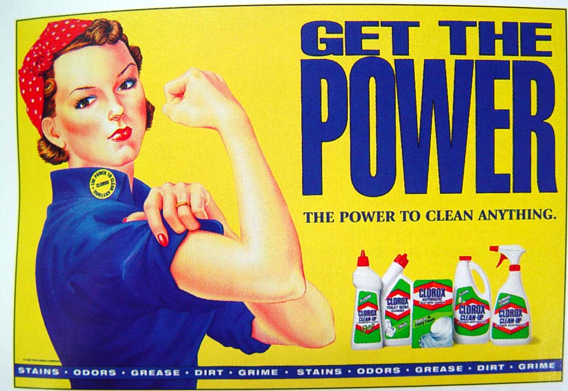

THIS PICTURE DOES NOT INCLUDE ALL THE LABOR THAT GOES INTO GETTING THINGS CLEAN. IF YOU BUY THIS PRODUCT YOU WILL NOT AUTOMATICALLY BE STRONGER NOR WILL YOU LOOK PRETTY.

**SUPPLIES**

**IT TAKES HARDWORK**